**Part 0**

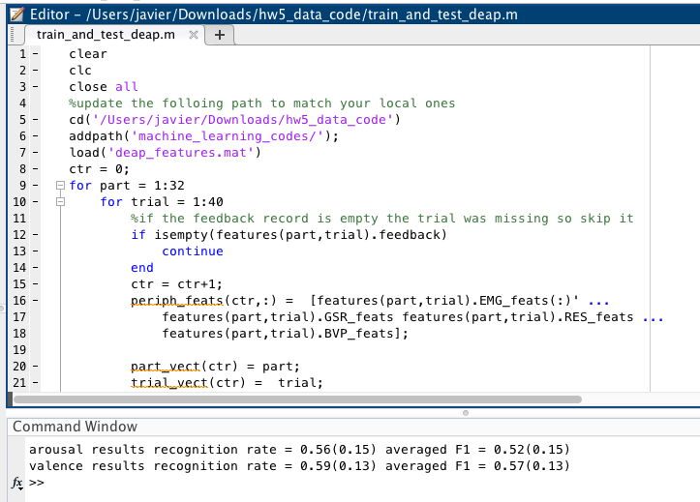

**Part 1**

1) The first for loop gives training data to build the Naives Bayer Classifier. Then, the second for loop uses the test results to evaluate them with the classifier. The results show the average recognition rate, which can be interpreted as correctly guessed tests or subjects divided by total tests or subjects, of arousal with the value of 0.56 and a standard deviation of 0.15. Additionally the F1 score is 0.52 with a standard deviation of 0.15. Simultaneously, the average valence recognition rate is 0.59 with a standard deviation of 0.13. Also, the F1 score is 0.57 with a standard deviation of 0.13. Since there is a relatively small standard deviation, that means the recognition rate data is grouped towards the center of the mean. This grouped data represents a natural distribution of the data.

2)

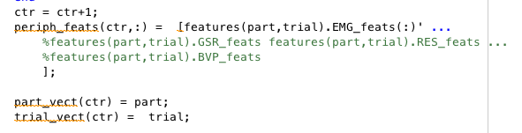

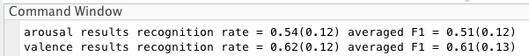

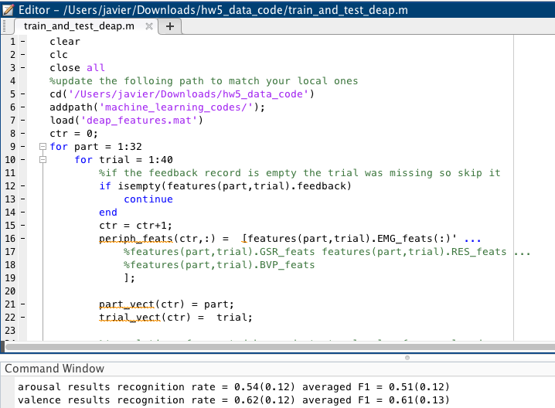

I am using the EMG (electromyogram: facial muscle activities) features in my test. As expected, there are some differences in the result compared to the results using the four types (EMG, GSR, RES, and BVP). The F1 score is higher for the valence, thus it means the test with one feature is slightly more accurate than with the four features. Furthermore, the EMG F1 score is 0.51 with a 0.12 standard deviation compared to the four features F1 score is 0.52 with a 0.15 standard deviation. Thus, the EMG F1 score has a slightly lower mean, but with a smaller distribution of data, possibly meaning that there is more accuracy on the EMG F1 score.

**Part 2**

1) I changed the normalize parameter from 3 to 1. Thus, instead of using a zscore, I am using min and std (standard deviation). Furthermore, I changed the classifier from diaglinear to diagquadratic.

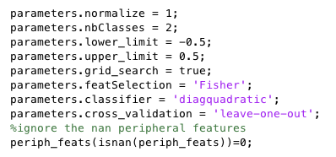

As a result, I ended up with similar results. The recognition rate slightly went down and the standard deviation increased slightly. Thus, the diaglinear classifier is better than the diagquadratic.

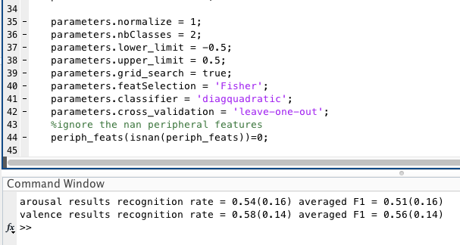

Arousal recognition rate is 0.54 with standard deviation of 0.16. F1 score is 0.51 with standard deviation of 0.16. Furthermore, valence results are 0.58 with standard deviation 0.14 and the F1 score is 0.56 with standard deviation of 0.14.

2) I found interesting that the dialinear classifier yielded a slightly better results than a diagquadratic classifier. In theory the more complex the classifier is (the higher degree), it should yield accurate results. Clearly, this is not the case.